Transfer entropy: NZDUSD and USDCHF
Method 17 / daily log returns / B=5 / lag=1 / Alpari D1 full available history

Study setup
Logical pair: NZDUSD , USDCHF
Broker symbols: NZDUSD_i , USDCHF_i
Snapshot: 2026-11-03_majors_alpari_D1
Timeframe: D1
Matched return window: 1999-01-05 to 2026-11-02 (UTC bar dates)
Matched return count n: 7185
Lag-aligned TE rows n_te: 7184
Dropped unfinished last bar dated 2026-11-03 UTC after a tick-volume check against the prior complete day.
Bins B=5; lag k=m=1
Units: nats (natural log)
Complete matched rows (Excel): NZDUSD-USDCHF_TE_D1.xlsx
Complete matched rows (HTML table): NZDUSD-USDCHF_TE_D1_data.html

Method carried forward
Transfer entropy TE_X->Y asks whether the past of X adds information about the next value of Y beyond Y's own past. Matched daily log returns of close, ln(close_t / close_t-1), are discretized into B=5 equal-frequency bins per series on the matched sample. Lag orders k=m=1. TE = H(Y_{t+1}|Y_past) - H(Y_{t+1}|Y_past, X_past) in nats. Both directions are reported. Quotes are not inverted. Same-sample Pearson r is a side check only. TE is directed predictive information in this discrete model — not structural causation and not a trading signal.

Results
TE_NZDUSD->USDCHF: 0.007344 nats
TE_USDCHF->NZDUSD: 0.005881 nats
Same-sample Pearson r: -0.393600

Conclusion
On 7184 lag-aligned rows for NZDUSD and USDCHF (B=5, lag=1), TE_NZDUSD->USDCHF = 0.007344 nats and TE_USDCHF->NZDUSD = 0.005881 nats. Same-sample Pearson r is -0.3936. This is discrete predictive information, not economic cause and not a trading signal.

Charts
Daily closes

Daily log returns

Transfer entropy both directions
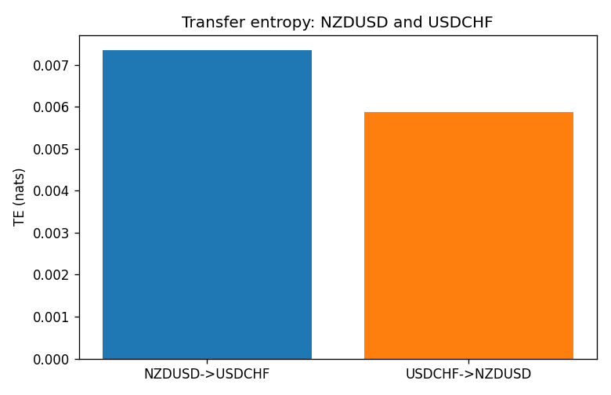

Data report
Every matched row is stored in the sibling Excel workbook named NZDUSD-USDCHF_TE_D1.xlsx, including bin labels. Embedding all rows as a Word table is impractical; this file holds column summaries and the first and last 15 matched rows.
Columns: time, NZDUSD_open, USDCHF_open, NZDUSD_high, USDCHF_high, NZDUSD_low, USDCHF_low, NZDUSD_close, USDCHF_close, NZDUSD_tick_volume, USDCHF_tick_volume, NZDUSD_spread, USDCHF_spread, NZDUSD_real_volume, USDCHF_real_volume, NZDUSD_log_return, USDCHF_log_return, NZDUSD_bin, USDCHF_bin
Column summaries (matched calculation rows)
column | count | mean | std | min | 25% | 50% | 75% | max
NZDUSD_open | 7185 | 0.65641395 | 0.10821881 | 0.3913 | 0.59137 | 0.6684 | 0.72499 | 0.88218
USDCHF_open | 7185 | 1.0976269 | 0.25248305 | 0.72022 | 0.92053 | 0.98988 | 1.2378 | 1.8219
NZDUSD_high | 7185 | 0.66033247 | 0.10871106 | 0.3961 | 0.59478 | 0.672 | 0.72937 | 0.88421
USDCHF_high | 7185 | 1.1029176 | 0.25422469 | 0.73305 | 0.92474 | 0.99353 | 1.2423 | 1.8313
NZDUSD_low | 7185 | 0.65272894 | 0.10781325 | 0.3897 | 0.58811 | 0.66417 | 0.72099 | 0.87988
USDCHF_low | 7185 | 1.0925083 | 0.25089773 | 0.08565 | 0.91719 | 0.98622 | 1.2317 | 1.8121
NZDUSD_close | 7185 | 0.65649284 | 0.10821292 | 0.3907 | 0.59165 | 0.6684 | 0.72502 | 0.8822
USDCHF_close | 7185 | 1.0976163 | 0.25237603 | 0.72025 | 0.92079 | 0.98995 | 1.2379 | 1.8217
NZDUSD_tick_volume | 7185 | 68718.644 | 123140.12 | 16 | 5587 | 33899 | 58511 | 1127682
USDCHF_tick_volume | 7185 | 74335.19 | 113494.16 | 18 | 12810 | 40241 | 70443 | 858589
NZDUSD_spread | 7185 | 30.278775 | 25.647496 | 0 | 9 | 17 | 40 | 80
USDCHF_spread | 7185 | 26.036326 | 24.697816 | 0 | 5 | 16 | 50 | 100
NZDUSD_real_volume | 7185 | 1.6703703e+10 | 8.4983725e+10 | 0 | 0 | 0 | 0 | 2.705649e+12
USDCHF_real_volume | 7185 | 2.3294091e+10 | 8.9133595e+10 | 0 | 0 | 0 | 0 | 1.9331921e+12
NZDUSD_log_return | 7185 | 2.019e-05 | 0.00763908 | -0.07027433 | -0.0042485 | 0.00023717 | 0.00458461 | 0.05966839
USDCHF_log_return | 7185 | -7.205e-05 | 0.00658891 | -0.19545699 | -0.0033516 | 8.095e-05 | 0.00331593 | 0.09051364
NZDUSD_bin | 7185 | 2 | 1.414312 | 0 | 1 | 2 | 3 | 4
USDCHF_bin | 7185 | 2 | 1.414312 | 0 | 1 | 2 | 3 | 4
First 15 matched rows (selected columns)
time | NZDUSD_close | USDCHF_close | NZDUSD_log_return | USDCHF_log_return | NZDUSD_bin | USDCHF_bin
1999-01-05 | 0.5372 | 1.3724 | -0.0018597736 | 0.0039424743 | 1 | 3
1999-01-06 | 0.5383 | 1.3912 | 0.0020455609 | 0.013605652 | 3 | 4
1999-01-07 | 0.5417 | 1.3782 | 0.0062963171 | -0.0093883841 | 4 | 0
1999-01-08 | 0.5414 | 1.3935 | -0.00055396548 | 0.011040268 | 2 | 4
1999-01-11 | 0.547 | 1.4009 | 0.010290425 | 0.0052963193 | 4 | 4
1999-01-12 | 0.5441 | 1.3872 | -0.0053157489 | -0.0098275602 | 1 | 0
1999-01-13 | 0.5387 | 1.3621 | -0.0099742238 | -0.018259701 | 0 | 0
1999-01-14 | 0.5386 | 1.3588 | -0.00018564931 | -0.0024256692 | 2 | 1
1999-01-15 | 0.5382 | 1.3834 | -0.00074294208 | 0.01794228 | 2 | 4
1999-01-18 | 0.5372 | 1.379 | -0.0018597736 | -0.0031856384 | 1 | 1
1999-01-19 | 0.5382 | 1.3789 | 0.0018597736 | -7.2518946e-05 | 3 | 2
1999-01-20 | 0.5404 | 1.3889 | 0.0040793678 | 0.0072259871 | 3 | 4
1999-01-21 | 0.5426 | 1.3836 | 0.0040627941 | -0.0038232689 | 3 | 1
1999-01-22 | 0.5361 | 1.3834 | -0.012051689 | -0.0001445609 | 0 | 2
1999-01-25 | 0.5342 | 1.3868 | -0.0035504102 | 0.0024546976 | 1 | 3
Last 15 matched rows (selected columns)
time | NZDUSD_close | USDCHF_close | NZDUSD_log_return | USDCHF_log_return | NZDUSD_bin | USDCHF_bin
2026-10-13 | 0.56127 | 0.83244 | 0.0047326165 | -0.0024955621 | 3 | 1
2026-10-14 | 0.55918 | 0.83489 | -0.0037306483 | 0.0029388325 | 1 | 3
2026-10-15 | 0.56185 | 0.82676 | 0.0047634855 | -0.0097855323 | 3 | 0
2026-10-16 | 0.56509 | 0.82377 | 0.0057501001 | -0.0036230826 | 4 | 1
2026-10-19 | 0.56616 | 0.82677 | 0.0018917133 | 0.0036351779 | 3 | 3
2026-10-20 | 0.56827 | 0.8246 | 0.0037199341 | -0.0026281224 | 3 | 1
2026-10-21 | 0.57003 | 0.82427 | 0.0030923331 | -0.00040027413 | 3 | 2
2026-10-22 | 0.56815 | 0.82032 | -0.0033035227 | -0.0048036381 | 1 | 0
2026-10-23 | 0.56991 | 0.82497 | 0.0030929853 | 0.005652514 | 3 | 4
2026-10-26 | 0.56826 | 0.82649 | -0.0028993932 | 0.0018407959 | 1 | 3
2026-10-27 | 0.56811 | 0.82865 | -0.00026399852 | 0.0026100526 | 2 | 3
2026-10-28 | 0.56261 | 0.82781 | -0.0097283914 | -0.0010142111 | 0 | 2
2026-10-29 | 0.56296 | 0.82379 | 0.00062190714 | -0.0048680164 | 2 | 0
2026-10-30 | 0.56307 | 0.82438 | 0.00019537668 | 0.00071594559 | 2 | 2
2026-11-02 | 0.56161 | 0.81851 | -0.0025962955 | -0.0071459744 | 1 | 0

